Clinical Research 1-Week Onboarding Plan

BEFORE Orientation:
- Register for Clinical Research Orientation at https://emory.brainier.com/#/login. Must have Emory University username and password. Contact 404.778.7777 for more information.
- Download the Clinical Research Checklist. Be sure to complete STEP 1.

MONDAY Day 1 – Orientation
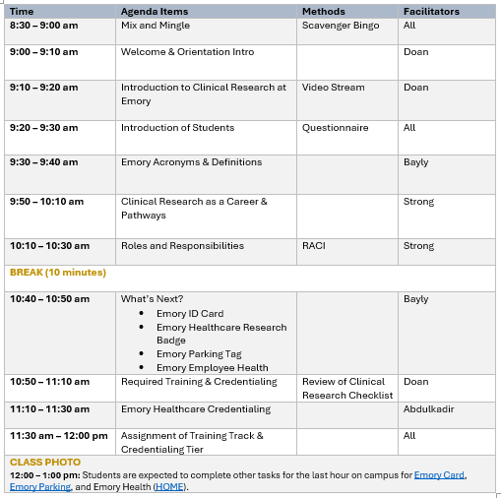

Tuesday: Day 2 – IN-HOUSE (Track 0)

Wednesd

TUESDAY: Day 2 – In-House Training
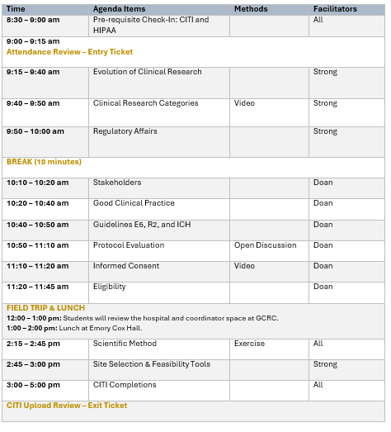

WEDNESDAY: Day 3 – Remote Day (1) – PRE-AWARD PROCESS
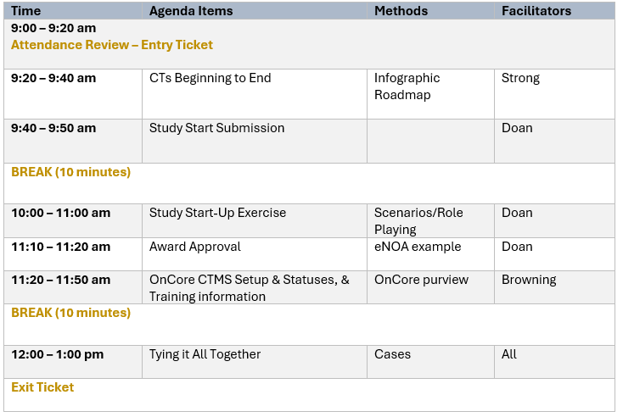

After Remote Day (1), register for both OnCore CTMS and Epic Training.

THURSDAY: Day 4 – Remote Day (2) – POST-AWARD PROCESS
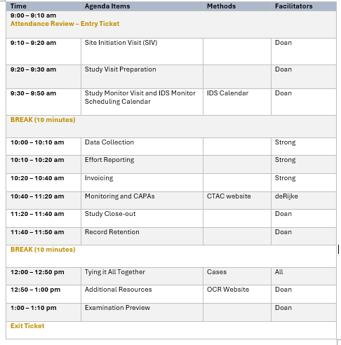

FRIDAY: Day 5 – SELF-PACE eLearning in Emory Brainer LMS
Self-Pace Modules
Pre-requisites (https://about.citiprogram.org/)
- CITI Biomedical and/or Biomedical Refresher
- CITI CRC (Clinical Research Coordinator)
- CITI Good Clinical Practice & ICH
- CITI Health Privacy and Information Security

eLearning Modules (https://emory.brainier.com/#/login)
*Note: You will only see these modules after staff-level tracked assignments, usually beginning the Friday of the 1-week onboarding process.

- Ancillary Departments
  - Emory Medical Laboratory – EML
  - Investigational Drug Services – IDS
  - Radiology Services
- Compliance
  - Audit and Inspections
  - Conflicts of Interest
  - CT.gov Compliance & Reporting
  - Research Misconduct
- Institutional Review Board (IRB)
  - Emory Informed Consent Form (ICF)
  - Emory IRB Submission
  - Reportable New Information (RNI)
- Medical Devices
- Research Administration Offices for Clinical Research
  - Environmental Health & Safety Office (EHSO)
  - Office of Sponsored Programs (OSP)
  - Research Administrative Services (RAS)
  - Research Grants and Contracts (RGC) – Award Setup
  - Research Grants and Contracts (RGC) – Award Closeout
- Software
  - Epic Medical Records at Emory Healthcare
  - OnCore Clinical Trials Management System (CTMS)
- Study Maintenance
  - Documentation
  - Standard Operating Procedures (SOPs)

SATURDAY– Following Monday by COB (5:00 pm EST) – EXAMINATION
After completing all assignments in your track, including Prerequisites and Self-Paced eLearning modules, the examination link will be provided. An email will be sent if for pass or remediation. View the Clinical Research Orientation and Training Course Failure Policy.

6-8 WEEKS – After the CRO/CRT training, the CTAC Department will contact you for the IN-FIELD training.
When CTAC contacts you view email, be sure to inform them of any monitoring reports and additional training you will need to know to coordinate your clinical trials. Utilize their various tools on their website at https://ctac.emory.edu/resources/index.html.

EVERY 3 YEARS – Renewal of Clinical Research Training – DUE at CITI Refreshers
Refresher Modules
Renewals (https://about.citiprogram.org/)
- CITI Biomedical Refresher
- CITI CRC (Clinical Research Coordinator)
- CITI Good Clinical Practice & ICH

Renewal eLearning Modules (https://emory.brainier.com/#/login)
*Note: Upload renewal certificates in your RedCap eCREST record.

- A total of 3.0 C Electives from GaCTSA – https://twd.ce.emorynursingexperience.com/.
- For Winship staff – they can use the Clinical Research Staff Annual Certificate of Completion.

