CLINICAL RESEARCH WELCOME CHECKLIST
Before you start, you must know your research duties and view the Emory Clinical Research Orientation &Training policy. Discuss with your Principal Investigator (PI) and/or Manager all clinical-related activities you may be performing within your role, as they will determine the trainings, immunizations, and additional requirements you will need. Complete and/or register for the following:
- ☐ Clinical Research Employee Training Profile.
To begin the training pathway for your role, please complete your research RedCap eCREST employee profile form using this link https://is.gd/eCREST.

- ☐ Emory University New Employee Welcome Session.
Emory’s New Employee Welcome Session is to better understand Emory's mission and culture and the benefits, programs, and resources available. You will be given the opportunity to register as part of your onboarding tasks. Departments and/or Managers may have additional orientation requirements (i.e., observing/shadowing, monitoring, reviewing SOPs, etc.)
- ☐ Immunization Requirements.
- Tuberculosis Antibody Testing (T-Spot, PPD)
- Hepatitis B and Hepatitis B Antibody Testing *
- Measles, Mumps, Rubella
- Varicella (Or Proof of Immunity)
- Flu* (If hired between October and March)
- COVID-19*
*Option to submit waiver

If you meet one or more of the following criteria:
- Work directly with human subjects (i.e., Escorting, Phlebotomy, Vitals, ECG)
- Any human subject interaction more than a handshake
- Handling human samples (i.e., Collecting, Transporting, Shipping, Processing, etc.)
Certain immunizations and antibody screenings are required for Emory Healthcare research credentialing verification.
You may schedule an appointment with Employee Health through the HOME website to schedule any vaccinations or antibody testing. Alternatively, you may obtain vaccinations from your preferred healthcare provider.

- ☐ Baseline Trainings/Pre-requisites.
The Collaborative IRB Training Initiative Program (CITI) is a leading online training program maintained by the University of Miami. It offers curricula in human subject research, animal research, and the responsible conduct of research. All Emory personnel conducting "human subject research" activities at Emory must take CITI. This includes anyone working with identifiable data or biological specimens for research purposes. This includes all roles: investigators, research nurses, coordinators, students, technicians, data collectors, and faculty advisors.
Click here for information and CITI registration instructions, and complete the following courses:
- Biomedical Focus (either Stage 1- Basic/ or Stage 3 – Refresher and/or Social Behavioral
- Good Clinical Practice and ICH (Group 5 for Emory University)
- Health Privacy and Information Security (i.e., HIPAA for Clinical Research Staff)
- Clinical Research Coordinator

5. ☐ Clinical Research Orientation & EHC Credentialing Review
The Clinical Research Orientation (CRO) & Emory Healthcare (EHC) Credentialing Review is required for all new hires, rehires, and those who have been promoted in a new clinical research role (excluding investigators that receive an orientation from their respective department) at Emory University and Emory Healthcare conducting or coordinating an NIH-definition of a clinical trial (PDF).
CRO is mandatory and in-person every 1st Monday of each month at the 1599 Clifton Road Building, 1st Floor, from 8:30 am – 1:00 pm. CRO will allow new hires/rehires/promotions to visit Emory Transportation for parking hangtags, Emory Administration for the Emory Card ID badge, and Emory Employee Health for health checkoffs.
EHC Credentialing is mandatory if you will be working at an Emory Healthcare facility (hospital, clinic, etc.) and/or need access to Emory Healthcare’s medical record system – Epic. Orientation will aid in fast-tracking staff through the EHC Credentialing process who meet specific criteria and have completed all required documentation from Step 1 above.
Training tracks will be identified and assigned at Orientation based on their clinical research experience and years at Emory University. To register for Clinical Research Orientation (CRO), follow the instructions below.
- Log in to the Emory Brainer Learning Management system.
- Enter your Emory University username and password.
- Search “Clinical Research Orientation.”
- Click “Register” for the date you want to attend.

6. ☐ EHC Research Credentialing Requirements
Per Step 5, speak with your PI and/or Manager to determine if you need to be credentialed. Staff that need credentialing are those that:
- Need access to Emory Healthcare’s Epic medical record system, or
- Recruiting or conducting research visits or activities in an Emory Healthcare facility, or
- Will perform clinical duties (i.e., Vital Signs, Phlebotomy, Height/ Weight measurements, ECGs) on human subjects, or
- Require access to Emory Healthcare facilities.
For questions, contact at research.credentialing@emoryhealthcare.org,
Or call 404.712.0510.

7. ☐ Clinical Research Training (CRT) and Training Tracks
Clinical Research Training (CRT) is required for all new hires, rehires, and those who have been promoted in a new clinical research role (excluding investigators that receive an orientation from their respective department) at Emory University and Emory Healthcare conducting or coordinating an NIH-definition of a clinical trial (PDF).
The training is based on years of experience in clinical research and the number of years at Emory University. The training provides the concepts of clinical research and the basic framework of the roles and responsibilities at Emory University to equip clinical research staff with the tools to be successful in their job roles. The clinical research training tracks are assigned at CRO per the table below.
Clinical Research Training Tracks and EHC Credentialing Tiers
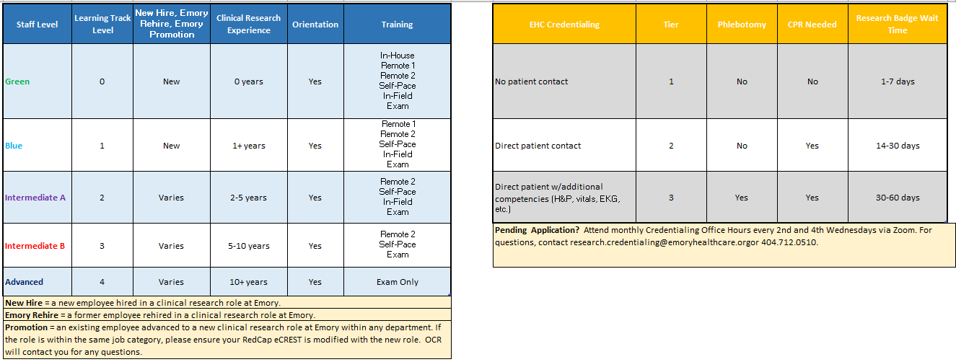

8. ☐ The Emory Clinical Research Orientation &Training policy.
This Emory Clinical Research Orientation &Training policy provides details on what is required to begin conducting or coordinating clinical research studies at Emory. Review the Office for Clinical Research (OCR) courses website page at https://ocr.emory.edu/resources/training/courses.html.

9. ☐ Additional Training after Clinical Research Training (CRT)
  - ☐ AHA BLS CPR Training
CPR training is required for those who fit EHC Credentialing Tier 2 and 3 and OCR will enroll you in a class at Clinical Research Orientation (OCR).
  - ☐ Conflict of Interest Training via eDisclose
COI training is required for all covered individuals; regardless of title or position, any person responsible for research design, conduct, or reporting should disclose financial interests. It is important that anyone who is involved with the design, conduct, or reporting of any research in particular disclose their financial interests.
  - ☐ Department’s Training or Standard Operation Procedures (SOPs)
Supplemental training and department SOPs review will be provided by your department. Each department has its own training and SOPs to ensure you understand things that will occur in your department’s internal processes, procedures, systems, and guidelines. We encourage you to ask your PI/Manager/Supervisor for assistance.
  - ☐ Environmental Health & Safety (EHSO) Training
EHSO training is required for is required annually for those working on protocols that involve biosafety, laboratory, shipping, and human bloodborne pathogens (including Grady campus or buildings (e.g., Ponce Clinic). View EHSO courses.
  - ☐ Systems Training
You will learn several systems at Emory University, but two main systems are required to manage clinical research/trials.
- Emory Healthcare Medical Records System – Epic. Contact your department’s access coordinator, and to view the Epic Checklist.
- Emory University Clinical Trials Management System – view OnCore Training.

10. ☐ Training Documentation
Provide this checklist to your PI/Manager/Supervisor to verify that you have completed all these steps for their records as part of your onboarding.

Step/Training | Date Completed
- Clinical Research Employee Training Profile.

- Emory University New Employee Welcome Session.
- Immunization Requirements.
- Baseline Trainings/Pre-requisites
- Clinical Research Orientation & EHC Credentialing Review
- EHC Research Credentialing Requirements
- Clinical Research Training (CRT) and Training Tracks
- The Emory Clinical Research Orientation &Training policy.
- Additional Training after Clinical Research Training (CRT)

- Training Documentation | If Steps 1-9 were completed, notate in your training log/documentation.

Name:
Signature:
Date: _______________

As always, we are here to assist you!
If you have questions about this checklist, contact
the Office for Clinical Research at OCR@Emory.edu or 404.778.4960.

