This document has been created by the Office for Clinical Research (OCR) to assist clinical research staff with Epic training/issues/questions/concerns.
TRAINING
- Contact your Epic Super User for training or education. A list of your departments Super Users can be found ….
- Review Training information at the Epic SharePoint site below https://emory.sharepoint.com/sites/EPIC/SitePages/Training.aspx.
QUESTIONS OR CONCERNS
There are several options to address questions or concerns regarding Epic.
- Contact Emory Healthcare 8-HELP by calling 404.778.4357.
- In Epic, click on the “Submit PRD Issue” button on the tool bar
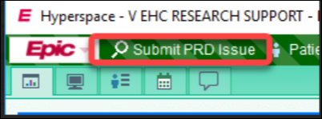
- On the Epic SharePoint site https://emory.sharepoint.com/sites/EPIC and scroll to the bottom, view the section below.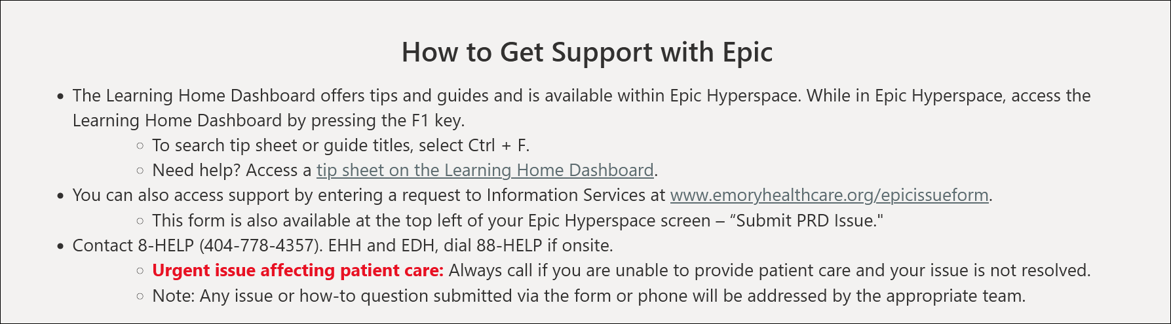

- In Emory VDT/Workspace, and logging on the Emory Healthcare Intranet, at the bottom of the page, it will indicate Support Information.
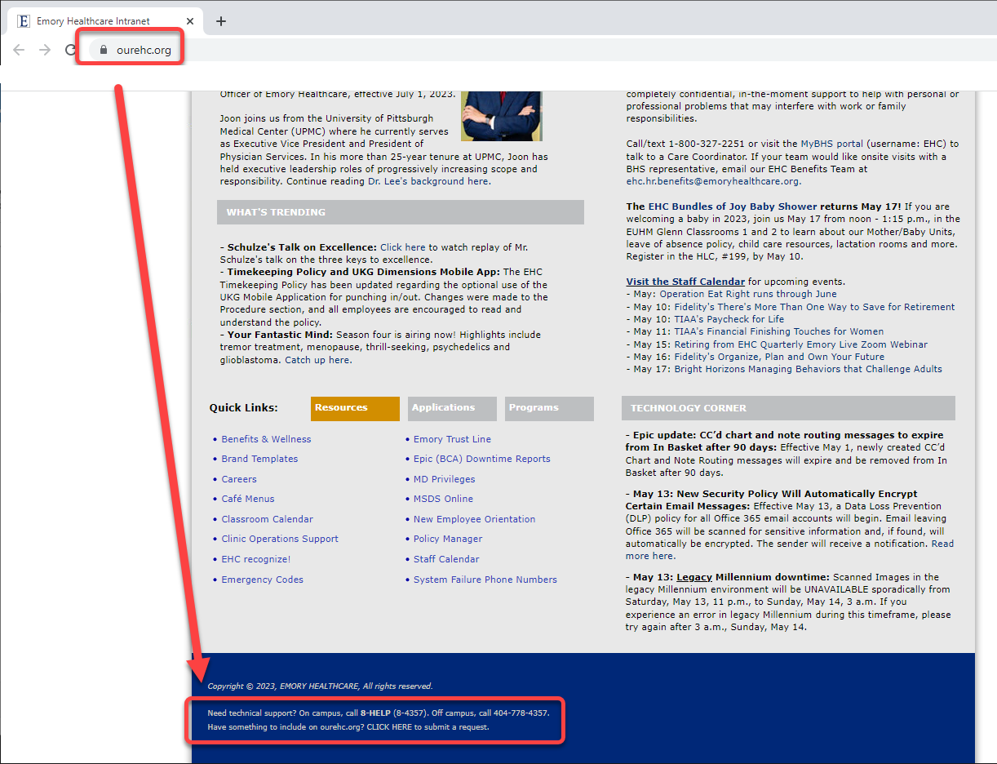
- Also, in Emory Healthcare Intranet, click “IS SERVICES & SUPPORT” tab > Report a Problem > Application.
