**How to Submit an Emory University ServiceNow Ticket**

**for OnCore Related Request**

1. Go to <https://help.emory.edu>
2. Log in to the Emory SSO (if necessary)
3. Click on the ‘Request Something’ link  
   A close-up of a white background

   AI-generated content may be incorrect.
4. Click on ‘Report an IT Incident’ to complete the questions outlined in the request form.

1. Please indicate in the question noted below that you have an OnCore related request by selecting one of these three options:
   1. OnCore – General: For all general requests
   2. OnCore – Non-Oncology: For request regarding non-oncology studies
   3. OnCore – Oncology: For request regarding oncology studies

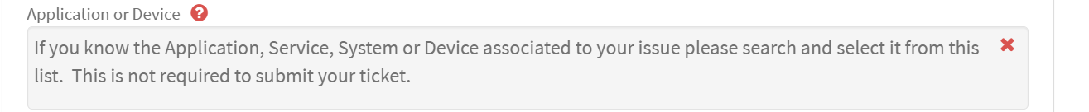

1. Click ‘Submit’ when you have completed the request form.

