Releasing Patient Groups to External Study Monitors

Effective October 23, 2024, research study coordinators will now be responsible for releasing patient groups in Epic to external study monitors. In Epic, a patient group is a list of patients that can be associated with multiple users within the organization and when a user is associated with a patient group, the user can access the record of each patient in that group.

Try It Out

1. The research study coordinator will log into Epic Hyperspace to **Release the Patient List**

from the **Actively Enrolled Patients** Dashboard report.

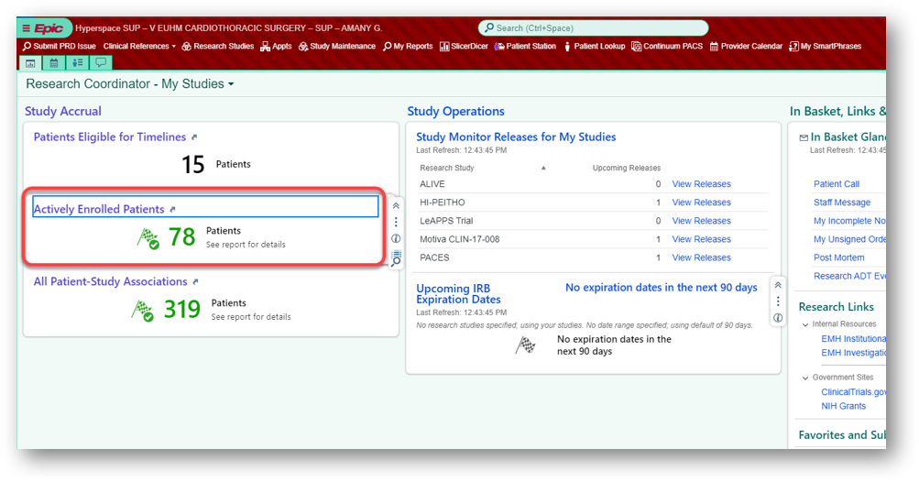

1. From the report results, highlight your patient row(s) and/or filter by study code or study name and then select the **Release to Study Monitor** activity button.

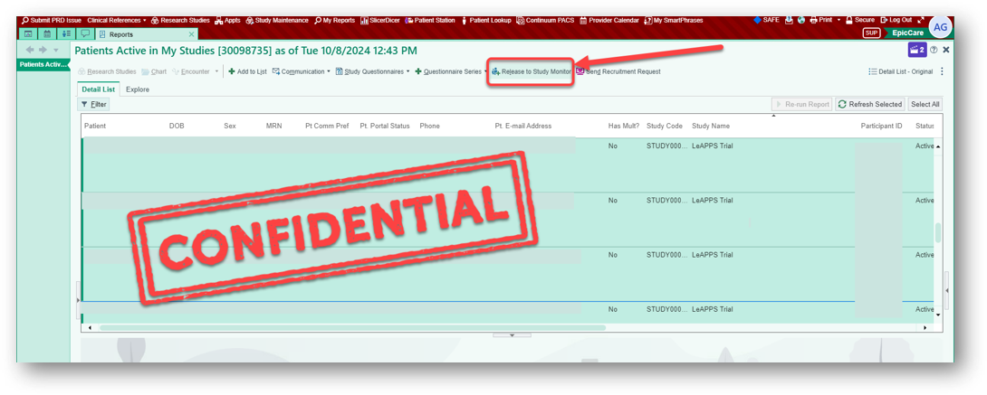

1. Once the **Release to Study Monitor** window opens, enter your research study code or

study name in the **Research Study** field.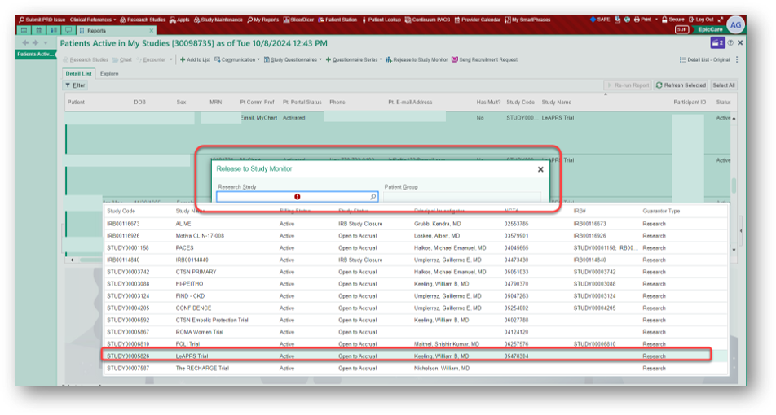

1. Enter the **Patient Group** and the **Release** **From** and **Release** **To Dates**. Click **Release.** Be sure to use the Patient Group information which will be provided to you in an email sent by the Emory Healthcare Epic Link Administrator.

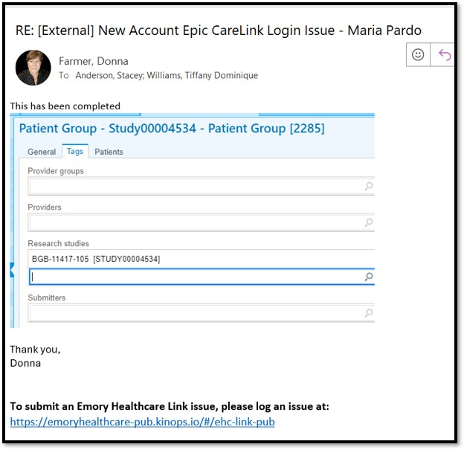

1. Use the Study Operations section of your Research Coordinator – My Studies dashboard to View **Study Monitor Releases** for your studies. A screenshot of a computer

   Description automatically generated

When you click on **View Releases**, you can review the associated study and patient group releases. This is a readily available tool for you to use in troubleshooting a study monitor’s potential issue with not being able to see the patient group or list. You can quickly verify the

release date range, research study and patient group from your dashboard view.

**The study monitor will have view-only access to the records you release via EpicCare Link.**

Troubleshooting and FAQs...

You Can Also…

* For more information, or to review the end-to-end research study monitor workflow, visit the Study Monitors section of the [OnCore SharePoint site](https://emory.sharepoint.com/sites/OnCore) and the Epic F1 Research and EpicCare Link Learning Home Dashboards.
* Review [Emory Healthcare Link FAQs](https://www.emoryhealthcare.org/medical-professionals/carelink/index.html)
* To submit an Emory Healthcare Link issue, please log an issue at:

<https://emoryhealthcare-pub.kinops.io/#/ehc-link-pub>